Cookies recipe
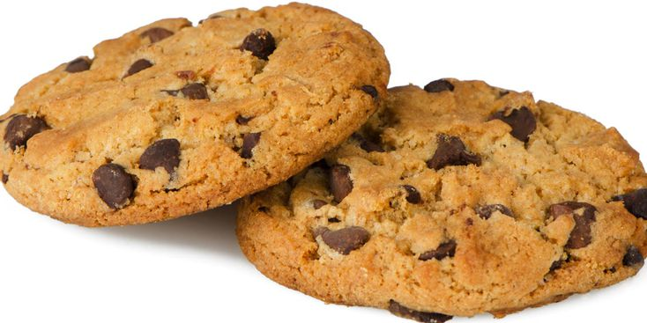
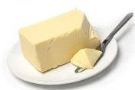
Ingredients :
• 80 g of butter
- 1 egg

- 85 g of sugar
- 1 vanilla sugar sachet
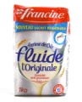
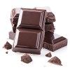
- 150 g of flour

- 100 g of dark chocolate
- 1 pinch of salt
- 1 raising powder sachet
Steps :

- Wash your hands !

- Cut the chocolate into chunks

- Put the butter in a bowl, add the sugar, the eggs and the vanilla sugar. Mix with your hands.

- Add the flour, the raising powder and the salt.

- Add the chocolate chunks. Mix again.

- Make little balls with the dough and put them on the grid. Make them flat with the back of the spoon.

- Put in the oven for 10 minutes, 180°.

